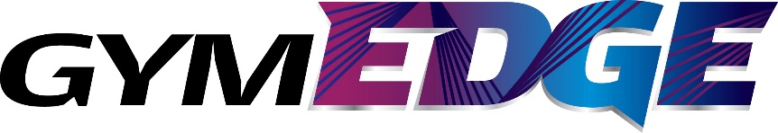

Fundamental Movement Skills Workshop
Booking Form 2018
This form must be completed and sent to sarah@gymnasticsireland.com to ensure the workshop can be approved.
Note: Please read through the Terms and Conditions for all additional information regarding this workshop. Click here to view.
By signing this form below, you are confirming that you have read, and agree with, the Terms & Conditions.
GymEDGE FMS Workshop
Date:
Please indicate preferred date and two alternates dates
Time:
Please indicate preferred start time
*Workshop is 6 hours in duration.
Venue:
Please provide details of the venue address
Facilities/ Equipment:
Please provide details of
- Size of venue
- how many gymnastic mats and benches are available
Numbers:
Please indicate the number of candidates attending
*Max. 20pax
If there is a larger group, a second tutor can be organised at an additional cost.
Details:
Lead contact Person/ Facilitator
Phone
Email
Signed: Date:

